Report of
Inventory Management System
Project

Instructor name | Dr. Hamad Naeem
Students Name | Hamzah Eyad – Abduallah Alsubaie
Students ID | 222453516 - 222421103
Section | 13
Course | Data structure and algorithms

Table of Contents

• Table of Contents: 2
• Introduction: 3
• Methodology 4
Pseudocode: 4
Executable Program code: 8
• Results and discussion 17
Input and Output Screenshots: 17
• Conclusion: 22

Introduction:

The Inventory Management System provides a practical solution for businesses to efficiently organize and control their product inventory. This console-based application leverages object-oriented programming principles to manage product information using linked lists. Users can easily perform key operations, including adding, removing, updating, and displaying products, making it a user-friendly tool for small to medium-sized businesses looking for a straightforward inventory management solution.

Methodology

Pseudocode:

Class Node:
private attributes:
string name
int productID
int quantity
double price
Node* next

public methods:
constructor(Node, string name, int productID, int quantity, double price):
set name, productID, quantity, price
set next to nullptr

setName(string newName):
set name to newName

getName():
return name

setProductID(int newProductID):
set productID to newProductID

getProductID():
return productID

setQuantity(int newQuantity):
set quantity to newQuantity

getQuantity():
return quantity

setPrice(double newPrice):
set price to newPrice

getPrice():
return price

setNext(Node* newNext):
set next to newNext

getNext():
return next

Class Inventory:
private attributes:
Node* head

public methods:
constructor(Inventory):
set head to nullptr

isEmpty():
return head is nullptr

isNewId(int id):
iterate over nodes in the list:
if current node's productID is equal to id:
return false
return true

isFound(int productID):
iterate over nodes in the list:
if current node's productID is equal to productID:
return true
return false

addProduct(string name, int productID, int quantity, double price):
create a new Node with given parameters
if list is empty:
set head to the new node
else:
iterate over nodes in the list:
find the last node
set the next of the last node to the new node

removeProduct(int productID):
if head's productID is equal to productID:
set temp to head
set head to head's next
delete temp
print "Product has been removed from inventory."
return
iterate over nodes in the list:
if next node's productID is equal to productID:
set temp to next node
set next of current node to next node's next
delete temp
print "Product has been removed from inventory."
return
print "Product was not found in inventory."

updateProduct(int productID, int newQuantity, double newPrice):
iterate over nodes in the list:
if current node's productID is equal to productID:
set quantity of current node to newQuantity
set price of current node to newPrice
print "Product has been updated."
return
print "Product was not found in inventory."

displayInventory():
if list is empty:
print "Inventory is empty."
return
print "Name\t|\tID\t|\tQuantity\t|\tPrice\n"
iterate over nodes in the list:
print current node's name, productID, quantity, price

Main Function:
create an instance of Inventory named inventory
create a variable choice
loop until choice is 5:
print menu
get user choice into choice
switch choice:
case 1:
get number of products to add
loop for each product:
get product details (name, productID, quantity, price)
check if productID is new
add product to inventory
break

case 2:
get productID to remove
remove product from inventory
break

case 3:
get productID to update
if product is found in inventory:
get new quantity and price
update product in inventory
else:
print "Product not found!"
break

case 4:
display inventory
break

case 5:
print "Exiting program."
break

default:
print "Invalid choice. Please try again."
break

Executable Program code:

#include <iostream>
#include <string>
#include <ctime>
using namespace std;

// Node class represents a single node in the linked list
class Node
{
private:
string name;
int productID;
int quantity;
double price;
Node* next;

public:
// Constructor to initialize the node with given values
Node(string name, int productID, int quantity, double price)
{
this->name = name;
this->productID = productID;
this->quantity = quantity;
this->price = price;
next = nullptr;
}

// Getter and setter functions for private member variables
void setName(string newName) { name = newName; }
string getName() { return name; }

void setProductID(int newProductID) { productID = newProductID; }
int getProductID() { return productID; }

void setQuantity(int newQuantity) { quantity = newQuantity; }
int getQuantity() { return quantity; }

void setPrice(double newPrice) { price = newPrice; }
double getPrice() { return price; }

void setNext(Node* newNext) { next = newNext; }
Node* getNext() { return next; }
};

// Inventory class manages the linked list of products
class Inventory
{
private:
Node* head;

public:
// Constructor to initialize an empty inventory
Inventory()
{
head = nullptr;
}

// Check if the inventory is empty
bool isEmpty()
{
return head == nullptr;
}

// Check if a given product ID is new (not already in the inventory)
bool isNewId(int id)
{
Node* current = head;
while (current != nullptr)
{
if (current->getProductID() == id)
{
return false;
}
current = current->getNext();
}
return true;
}

// Check if a product with a given ID is found in the inventory
bool isFound(int productID)
{
Node* current = head;
while (current != nullptr)
{
if (current->getProductID() == productID)
{
return true;
}
current = current->getNext();
}
return false;
}

// Add a new product to the inventory
void addProduct(string name, int productID, int quantity, double price)
{
Node* newNode = new Node(name, productID, quantity, price);

if (isEmpty())
{
head = newNode;
}
else
{
Node* current = head;
while (current->getNext() != nullptr)
{
current = current->getNext();
}
current->setNext(newNode);
}
cout << "Product added to inventory." << endl << endl;
}

// Remove a product from the inventory based on its product ID
void removeProduct(int productID)
{
if (head->getProductID() == productID)
{
Node* temp = head;
head = head->getNext();
delete temp;
cout << "Product has been removed from inventory." << endl << endl;
return;
}

Node* current = head;
while (current->getNext() != nullptr)
{
if (current->getNext()->getProductID() == productID)
{
Node* temp = current->getNext();
current->setNext(temp->getNext());
delete temp;
cout << "Product has been removed from inventory." << endl << endl;
return;
}
current = current->getNext();
}

cout << "Product was not found in inventory." << endl << endl;
}

// Update the quantity and price of a product in the inventory
void updateProduct(int productID, int newQuantity, double newPrice)
{
Node* current = head;
while (current != nullptr)
{
if (current->getProductID() == productID)
{
current->setQuantity(newQuantity);
current->setPrice(newPrice);
cout << "\nProduct has been updated." << endl << endl;
return;
}
current = current->getNext();
}
cout << "Product was not found in inventory." << endl << endl;
}

// Display the current state of the inventory
void displayInventory()
{
if (isEmpty())
{
cout << "Inventory is empty." << endl << endl;
return;
}

cout << "\t\t\t**Inventory**" << endl << endl;

Node* current = head;
cout << "Name\t|\tID\t|\tQuantity\t|\tPrice\n\n";
while (current != nullptr)
{
cout << current->getName() << "\t|\t" << current->getProductID() << "\t|\t" << current->getQuantity() << "\t\t|\t" << current->getPrice() << endl;
current = current->getNext();
}
}
};

int main()
{
Inventory inventory;
char choice;

// Display a welcome message
system("cls");
cout << "\n\n\n\n\n\t\t\t\t Welcome To Inventory Management System\n\n\t\t\t\t\tPress Enter to continue.";
cin.get();

do
{
// Display the menu
system("cls");
cout << "------------------------" << endl;
cout << "\n Menu:" << endl;
cout << "\n1. Add a product" << endl;
cout << "2. Remove a product" << endl;
cout << "3. Update a product" << endl;
cout << "4. Display inventory" << endl;
cout << "5. Exit" << endl;
cout << "\nEnter your choice: ";
cin >> choice;
cout << endl;
system("cls");

// Perform the chosen operation based on user input
switch (choice)
{
case '1':
{
// Add a new product
int num;
string name;
int productID, quantity;
double price;
cout << "\t--add a product--\n\n";
cout << "How many products would you like to add? ";
cin >> num;
for (int i = 0; i < num; i++)
{
cout << "\nEnter product '" << i+1 << "' name: ";
cin.ignore();
getline(cin, name);
cout << "Enter product ID: ";
cin >> productID;
while (!inventory.isNewId(productID))
{
cout << "Product ID already exists. Please enter a new ID: ";
cin >> productID;
}
cout << "Enter quantity: ";
cin >> quantity;
cout << "Enter price: ";
cin >> price;
inventory.addProduct(name, productID, quantity, price);
}
cout << "\t\t\t\t \nPress Enter to continue \n";
cin.ignore();
cin.get();
system("cls");

break;
}
case '2':
{
// Remove a product
int productID;
cout << "\t--remove a product--\n\n";
if(inventory.isEmpty())
{
cout << "Inventory is empty." << endl << endl;
cout << "\t\t\t\t \nPress Enter to continue \n";
cin.ignore();
cin.get();
system("cls");
break;
}
cout << "Enter product ID to remove: ";
cin >> productID;
inventory.removeProduct(productID);
cout << "\t\t\t\t \nPress Enter to continue \n";
cin.ignore();
cin.get();
system("cls");
break;
}
case '3':
{
// Update a product
int productID, newQuantity;
double newPrice;
cout << "\t--update a product--\n\n";
cout << "Enter product ID to update: ";
cin >> productID;
if (inventory.isFound(productID))
{
cout << "\nEnter new quantity: ";
cin >> newQuantity;
cout << "Enter new price: ";
cin >> newPrice;
inventory.updateProduct(productID, newQuantity, newPrice);
cout << "\t\t\t\t \nPress Enter to continue \n";
cin.ignore();
cin.get();
system("cls");
}
else
{
cout << "\nProduct not found!" << endl;
cout << "\t\t\t\t \nPress Enter to continue \n";
cin.ignore();
cin.get();
system("cls");
}
break;
}
case '4':
{
// Display the inventory
inventory.displayInventory();
cout << "\t\t\t\t \nPress Enter to continue \n";
cin.ignore();
cin.get();
system("cls");
break;
}
case '5':
{
// Exit the program
cout << "Exiting program." << endl;
cout << "\t\t\t\t \nPress Enter to continue \n";
cin.ignore();
cin.get();
system("cls");
break;
}
default:
{
// Invalid choice
cin.ignore();
cout << "Invalid choice. Please try again." << endl;
cout << "\t\t\t\t \nPress Enter to continue \n";
cin.ignore();
cin.get();
system("cls");
break;
}
}

} while (choice != 5);

return 0;
}

Results and discussion:

Input and Output Screenshots:

When you start the program this page will appear to you:



After pressing enter you will see the main menu:

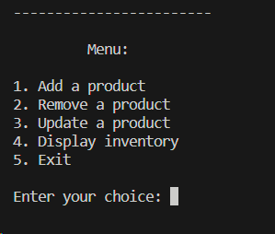

If you want to add a product choose 1; and you will see this page:

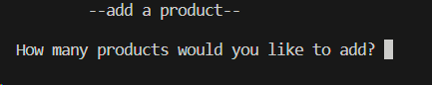

For example: if you need to add 2 products you will see these choices and you will fill that:

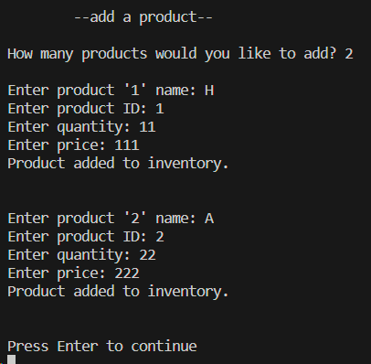

After pressing enter you will be back to the main menu, and if you choose to display the inventory enter 4 then you will see this page:

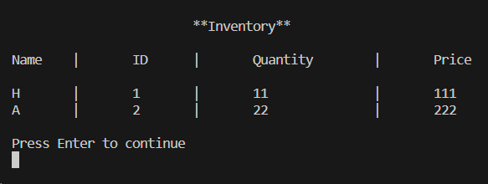

After pressing enter you will be back to the main menu again, and if you want to remove any product you can enter 2 and you will see this page:

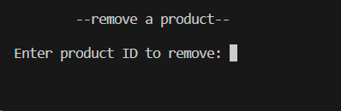

Here you should enter an ID that exist in the inventory, if you don’t you will see this message:

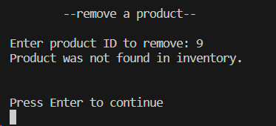

If you enter a valid ID like the example below the product will be deleted from the inventory, and you will see this message:

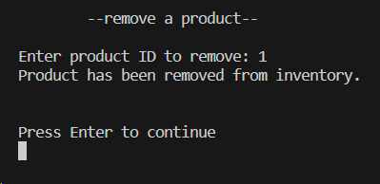

After pressing enter you will also go back to the main menu; and if you want to update a product information you can choose 3; and you will see this page:

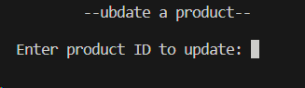

And here also you should enter a valid ID or will receive an error message; if you enter a valid ID you will see this, and after that the product will be updated in the inventory:

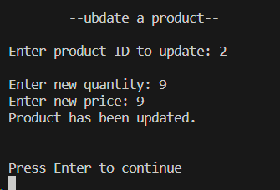

Now if you display the inventory you will see this page:

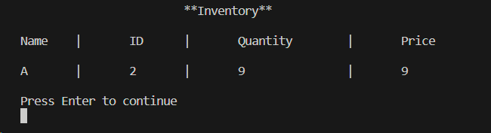

If you press enter you will go to the main menu, and if you want to exit you can press 5 and the program will be terminated:

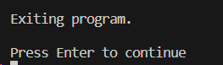

Conclusion:

In conclusion, this Inventory Management System serves as a practical demonstration of basic inventory control functionalities. It showcases the use of linked lists to dynamically manage product entries, ensuring flexibility and scalability. The program fosters good coding practices, encapsulating product details within a node and leveraging class methods for efficient data manipulation. As a console application, it offers a straightforward experience for users to manage their inventory, making it suitable for small to medium-scale businesses. This project can serve as a foundation for further enhancements, such as incorporating file I/O for persistent data storage or developing a graphical user interface for a more polished user experience.

